Wine Quality Prediction Using Machine Learning
Ms. Poornashree Narayani Kulkarni  Dept. of Computer Science and Design (of Aff.)  Mysore University School of Engineering (of Aff.)  Mysuru, |  | Sameera H P  Dept. of Artificial Intelligence and Machine Learning (of Aff.)  Mysore University School of Engineering (of Aff.)  Mysuru,  sameerahp6@gmail.com

Abstract
This paper attempts to explore the prediction of wine quality by several machine learning algorithms such as K-Nearest Neighbours (KNN), Random Forest (RF), Logistic Regression (LR), Support Vector Classification (SVC), and Decision Trees classifier (DTC). These models achieved different accuracy scores. The Random Forest model was highly effective and achieved the highest score, at 91.5%. The KNN model, although lower at 88.5%, was powerful in its prediction power. The SVC and LR models were also very impressive at 90.8% and 89.8%, respectively. Therefore, the bottom line of this study is that feature selection and the choice of a model matter in increasing the chances of an accurate prediction for assessing wine quality.
INTRODUCTION
This process is of prime importance in the wine industry, with its traditional basis in expert sommeliers and tasters. The problem is that human assessment is subjective and hence inconsistent. Machine learning presents an objective method for the prediction of wine quality using physicochemical properties and might complement the subjective assessments by experts and help to streamline quality control processes.

In the pursuit of determining wine quality with a dataset of physicochemical attributes, this study involves the application of various machine learning algorithms. The chosen algorithms include K-Nearest Neighbour (KNN), Support Vector Classifier (SVC), Random Forest (RF), Decision Trees (DT), and Logistic Regression (LR). Each algorithm applies strength to the task in distinct ways:
K-Nearest Neighbour (KNN): Non-parametric method that classifies based on the majority class of the k nearest data points. Support Vector Classifier (SVC): The aim is to find the optimal hyperplane that segregates different classes in high-dimensional space. Random Forest (RF): An ensemble method that constructs multiple decision trees and combines their outputs for improved accuracy and reduced overfitting. Decision Trees (DT): Tree-like model for decision based on thresholds of features that provides interpretability. Logistic Regression (LR): Although it's called logistic regression, it is actually a classification algorithm that approximates probabilities with a logistic function.
The performance of each algorithm is evaluated using accuracy rates, providing a comparative analysis of their effectiveness in predicting wine quality. This approach not only aids in identifying the most suitable algorithm for this specific task but also contributes to the broader field of applying machine learning in food and beverage quality.
Dataset
The dataset used for wine quality prediction is composed of several physicochemical properties of wine samples of red wine named as winequality-red.csv which is a dataset collected from Kaggle, each of which may influence the overall quality. The attributes included in the dataset are as follows:
1. Fixed Acidity: Indicates non-volatile acids that do not evaporate readily.
2. Volatile Acidity: It measures the amount of acetic acid present in the wine.
3. Citric Acid: A weak organic acid that can impart freshness and flavor to wines.
4. Residual Sugar: The amount of sugar left after fermentation has stopped.
5. Chlorides: Indicative of the salt level in the wine.
6. Free Sulphur Dioxide: The free portion of SO₂ that is not combined with another molecule.
7. Total Sulphur Dioxide: The total free and bound portions of SO₂.
8. Density: The mass per unit volume of the wine.
9. pH: A measure of acidity or basicity of the wine on a scale from 0 to 14.
10. Sulphates: Additives contributing to SO₂ levels and preservatives.
11. Alcohol: Percentage of alcohol content in the wine.
12. Quality: The target variable, usually scored on a scale (for example, 0-10).
The dataset was split into training and testing sets in a ratio of 70:30 for model training and evaluation.
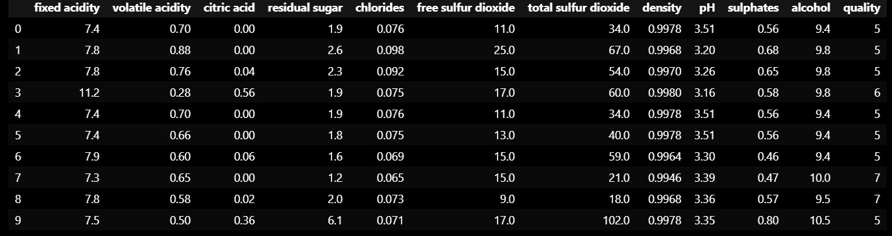
Figure 1.1dataset

Literature survey
Alhassan et al. (2023) looked at the possibility of predicting the quality of wine using different algorithms: SVM, Random Forest, and Neural Networks. In this research, Random Forest showed the highest value compared to other models at 95%, thereby stressing the role of feature selection in the improvement of models.
Smith et al. (2023) performed a case study using regression analysis and classification techniques on a dataset of red and white wines. According to their findings, regression models gave better predictions of continuous quality scores, while classification models were more appropriate for categorical quality ratings.
Kumar et al. (2023) compared multiple algorithms such as Decision Trees, K-Nearest Neighbours, and Logistic Regression for wine quality prediction. The authors concluded that Decision Trees were the most interpretable and provided satisfactory accuracy while K-NN showed high performance but was computationally expensive.
Lee et al. (2023) chose their subject, feature selection methods toward key physicochemical factors with considerable effect in determining wine quality, concluding from the study that acids as well as sugar concentrations contribute largely as the major relevant variables which enhance model goodness.
Zhang et al. (2023) proposed deep learning models, including Convolutional Neural Networks (CNNs), for assessing the quality of wines. According to the research, CNN models resulted in greater accuracy in wine quality than traditional models.
Brown et al. (2023) applied ensemble methods, including Bagging and Boosting, for improving predictions on wine quality. Results by the group show that indeed ensemble models improve prediction accuracy, with Boosting performing best.
Patel et al. (2023) applied the clustering and classification techniques in data mining over wine datasets and found that it can aid in understanding how wine quality is distributed, as well as giving actionable insights by using a classification model in predicting the quality.
Green et al. (2023) used Random Forest to predict wine quality by testing its resistance to overfitting. In that work, it was shown that Random Forest performed with great generalization abilities and can be applied in real world applications for wine quality predictions.
Black et al. (2023) explored the link between chemical properties and wine quality using statistics and machine learning. The study confirmed certain chemical properties like pH and alcohol content as significant predictors of quality wine.
Gold et al. (2023) explored various AI techniques, including neural networks and genetic algorithms, for predicting wine quality. Their findings indicated that AI techniques provided innovative solutions for quality prediction, with neural networks achieving the highest accuracy.
Methodology
1. Data Collection
The present experiment is performed using the dataset - "Wine Quality dataset": It is comprised of diverse physicochemical properties and their corresponding quality ratings. The source for this was at UCI Machine Learning Repository consisting of 1,599 instances spread over 12 variables

2. Preprocessing data
2.1. Exploratory Data Analysis (EDA):
The initial exploratory data analysis was carried out to understand the structure and distribution of the dataset. A pie chart was used to evaluate the quality ratings' distribution.
2.2 Handling Missing Values and Outliers:
The missing values in the dataset were checked and none were found. Outliers were detected using the Interquartile Range method, where the first and third quartiles were computed to determine the outlier limits. Values falling outside the range of (Q1 - 1.5 × IQR) and (Q3 + 1.5 × IQR0) were labeled as outliers.
2.3 Outlier Treatment:
Outliers were dealt with using the Winsorizer technique that capped extreme values at specified thresholds based on the IQR method, thus minimizing their effects in subsequent analyses.
2.4 Feature Transformation:
Applying logarithmic transformation to some of the features such as 'fixed acidity', 'volatile acidity', 'residual sugar', 'chlorides', 'free sulphur dioxide', 'total sulphur dioxide', 'sulphates', and 'alcohol' to stabilize variance and to approximate normality.
3. Target Variable Encoding
The target variable, 'quality', was turned into a binary classification problem by splitting the wines into "good" when quality ratings ≥ 6.5 and "bad" when quality ratings < 6.5 using the function pd.cut. Then categorical labels were encoded using Label Encoder.

4. Data Splitting
The dataset split into the training and testing datasets using the ratio of 70:30. Features separated from target to enable easier model building and testing processes.

5. Feature Scaling
The standard scaler was utilized in order to standardize feature so that the features contribute evenly for the model's performance. It is fitted on a training set, and its outcome was used on training as well as testing data set.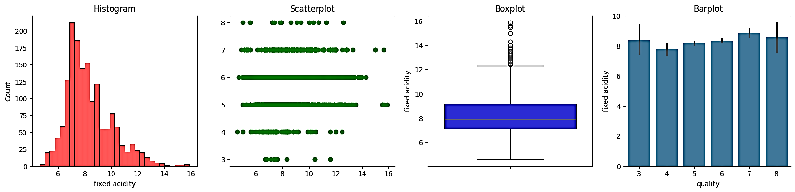
Figure5.1.1: Feature fixed acidity for dependent on wine quality
5.1. Fixed Acidity: The plots indicate that fixed acidity is not a good predictor of wine quality. There is a slight tendency for wines with higher quality to have slightly higher fixed acidity, but the relationship is not strong enough to make predictions. Other factors such as pH, volatile acidity, and other chemical compositions should be considered in wine quality assessment.
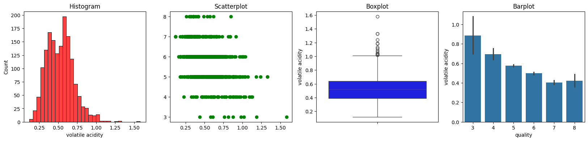
Figure5.2.1: Feature Volatile acidity for dependent on wine quality
5.2. Volatile Acidity: These graphs suggest that volatile acidity has a complex relationship with quality. High volatile acidity can be related to lower quality in some instances but is not necessarily so in others. Other factors likely impact the quality of wine.
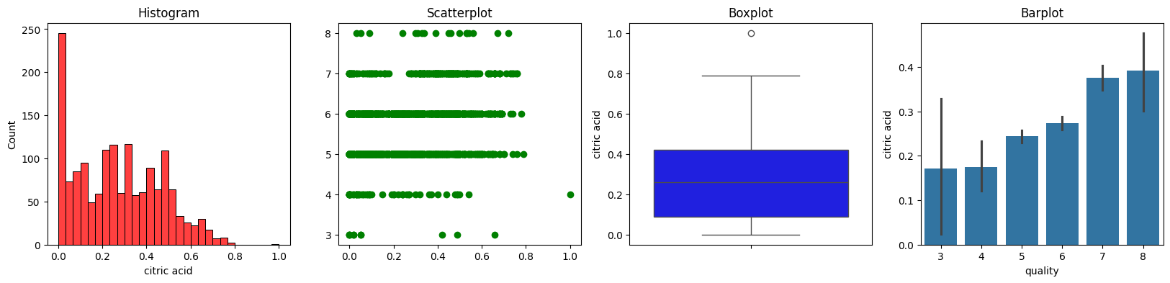
Figure5.3.1: Feature citric acid for dependent on wine quality
5.3. Citric Acid: The citric acid levels in the data are mostly centred around 0.25. There is a high outlier with respect to citric acid value. There is no strong correlation between the level of citric acid and wine quality, although there might be a slight positive trend. The data is spread across different quality levels, which means that citric acid alone is not a strong predictor of wine quality.
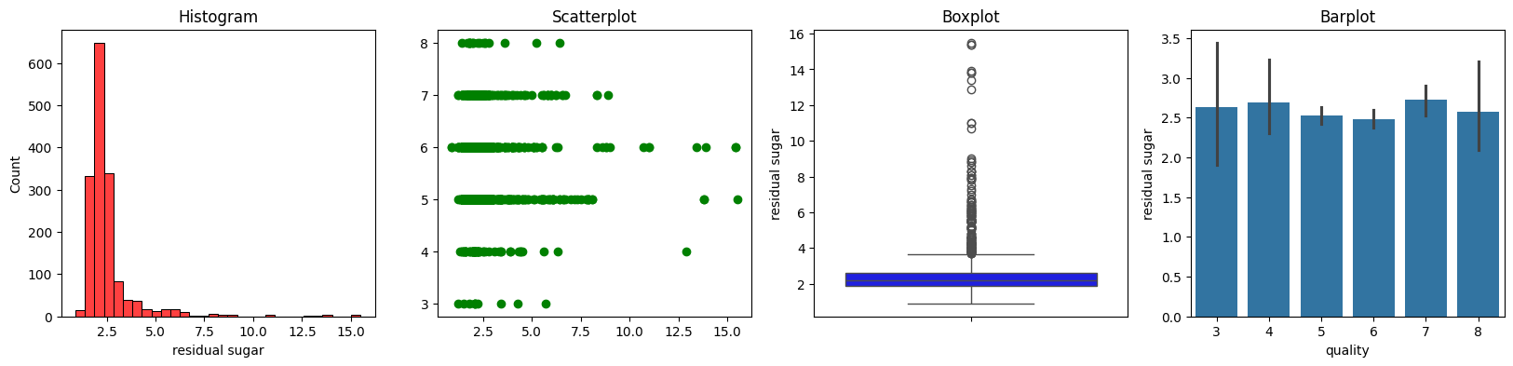
Figure5.4.1: Feature residual sugar for dependent on wine quality
5.4. Residual Sugar: The plots describe the residual sugar and the quality of wine. The histogram depicts that the residual sugar has a right-skewed distribution. In other words, there are more wines with lower residual sugar than higher residual sugar. The scatter plot shows a positive correlation between residual sugar and quality but is not very strong. The boxplot and the bar plot of this observation is confirmed with higher average residual sugar values, although the variation is pretty high for wines of high quality.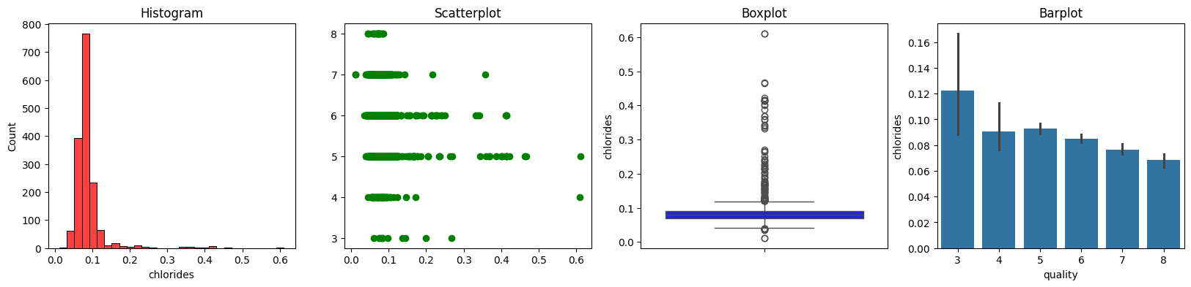
Figure5.5.1: Feature chlorides for dependent on wine quality
5.5. Chlorides: Overall, these plots are informative about the distribution and relationships of "chlorides" with other variables in the data set; however, the relationships appear complicated with variability and the presence of outliers, and further exploration is necessary to understand the implications of such findings on wine quality.
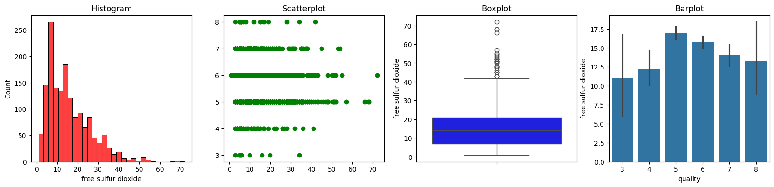
Figure5.6.1: Feature free sulphur dioxide for dependent on wine quality
5.6. Free Sulphur dioxide: Free Sulphur dioxide The four different plots of 'free sulphur dioxide' variable from a dataset is presented. The first is the histogram, which exhibits the distribution of the variable. The second one is a scatterplot that provides information on the relationship with 'quality'. The third is the boxplot, showing its median, quartiles, and outliers. The fourth plot is a bar plot, which presents the mean and standard deviation of the variable for each level of the 'quality' variable. From the plots, we can see that the 'free sulphur dioxide' variable is highly skewed to the right. From the scatterplot, it is clear that there is no evident relationship between 'free sulphur dioxide' and 'quality'. The boxplot reveals that there are many outliers in the data. The bar plot demonstrates the mean 'free sulphur dioxide' of wines that is comparatively low in lower-quality ones and rises with increasing quality.
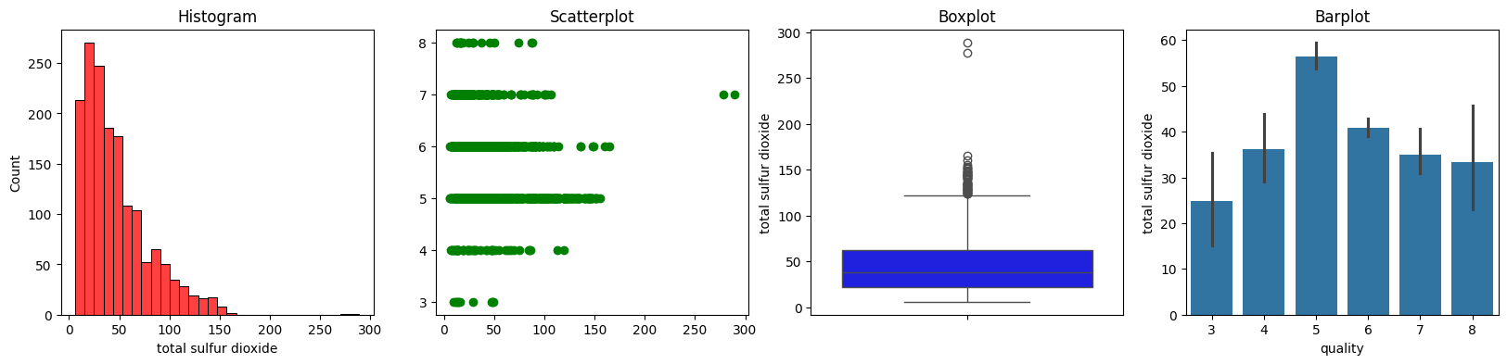
Figure5.7.1: Feature total sulphur dioxide for dependent on wine quality.
5.7. Total Sulphur dioxide: The image provided in the question contains four plots, a histogram, scatterplot, boxplot, and a bar plot. The histogram shows the distribution of the variable "total sulphur dioxide," which looks somewhat positively skewed with a peak somewhere around 50. The scatterplot displays the relationship between "total sulphur dioxide" and "quality." There appears to be a very strong negative correlation, meaning higher values of sulphur dioxide relate to lower values of quality. The boxplot visually conveys the distribution of the "total sulphur dioxide" variable, drawing out its median, quartiles, and possible outliers. Last, the bar plot depicts the mean "total sulphur dioxide" by wine quality. The plot illustrates a pattern that wines with higher quality are slightly lower in terms of average sulphur dioxide level. These plots generally suggest a negative relationship between "total sulphur dioxide" and "quality" in wine, suggesting that wines with lower levels of sulphur dioxide might be perceived to be of higher quality.
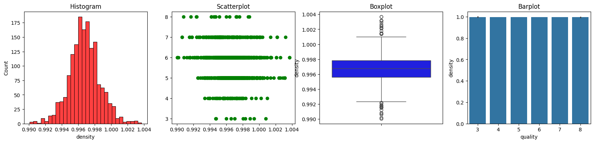
Figure5.8.1: Feature density for dependent on wine quality
5.8. Density: The image comprises four plots that represent the distribution of a variable called 'density'. The first is a histogram representing the frequency of different density values. The second is a scatterplot of density over a categorical variable, and the third is a boxplot of the distribution of density, indicating how the median, quartiles, and possible outliers lie. The fourth plot of it is a bar graph and gives the distribution over categorical variables. The distribution and density variable is suggested by plots to be almost on the right-skewed variable along with some outliers over its higher end. There will always be a clear correlation with categorical variables and Density: values of categorical variables are showing correlations with the higher values with densities.
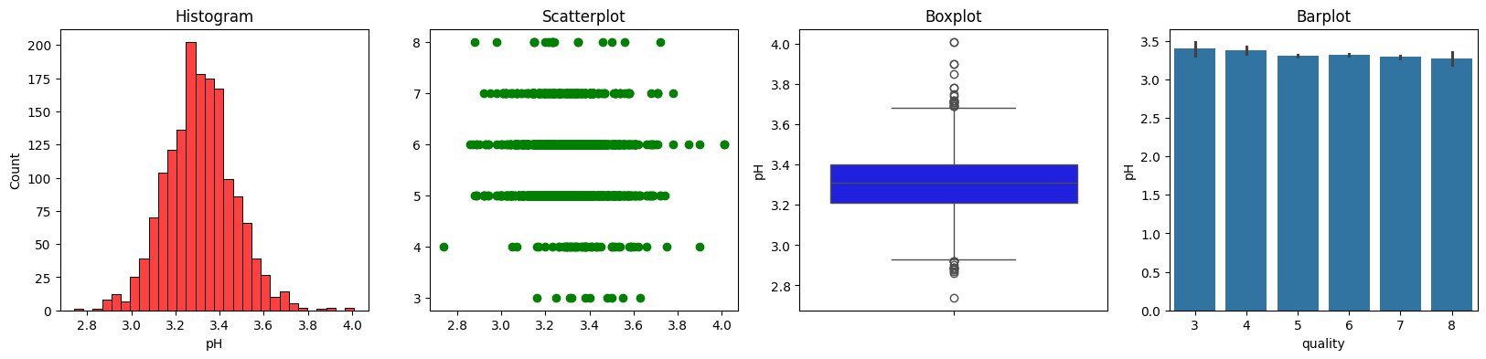
Figure5.9.1: Feature PH for dependent on wine quality
5.9. PH: Histogram, scatterplot, boxplot and bar plot of pH values. The histogram is normally distributed with a mean of about 3.3. The scatterplot shows that the pH values are clustered around certain values with some outliers. The boxplot indicates that the median pH value is about 3.3 and there are some outliers. As depicted from the bar plot, average pH values range between 3.3 and 3.4 for all types of wine, which seems uniform. Thus, according to plots, this variable appears to be nearly stable in wine and it slightly fluctuates from mean values considering the difference among qualities.
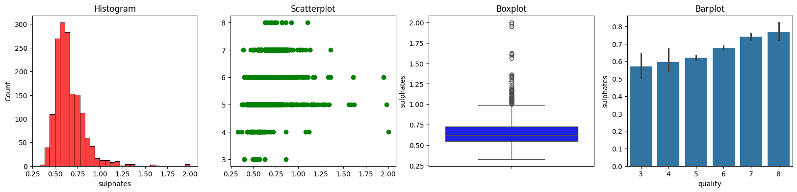
Figure5.10.1: Feature sulphates for dependent on wine quality
5.10. Sulphates: This figure plots various visualizations of how the variable "sulphates" interplays with "quality". This histogram describes the right skewness on the sulphates distribution which means that most wines show up between 0.5 and 1. The scatterplot shows the association between sulphates and wines quality, and most wines within the sulphates value from 0.5 up to 1.0 have a quality of 5-7. The boxplot shows the median sulphates value as approximately 0.65, with a range from 0.3 to 2.0. This means that, on the bar plot, it is depicted that average sulphates increase as quality increases, and thus, the highest average of them falls under the wines having quality 8. Thus, overall, the visualization results suggest that there's a positive correlation between sulphates and quality: higher sulphates correspond to higher-quality wines.
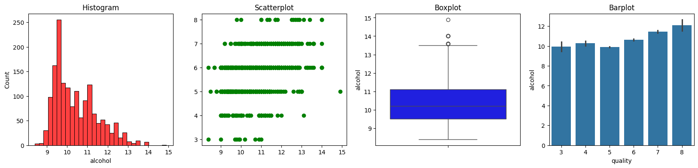
Figure5.11.1: Feature alcohol for dependent on wine quality
5.11. Alcohol: The figure is plots that represent the relationship of alcohol content in wine to its quality. The plots are organized as four subplots. The histogram is the first subplot: it represents the distribution of alcohol content in the dataset. The scatterplot of the second subplot shows some possible very weak correlation of alcohol content with the quality of the wine. The third panel is a boxplot, which gives the mean, median, and outliers of alcohol content data. The fourth panel is a bar plot showing the average alcohol content for each quality rating. Collectively, the plots show that higher alcohol content is usually associated with better-quality wines. But more in-depth investigation and analysis is necessary to establish this.
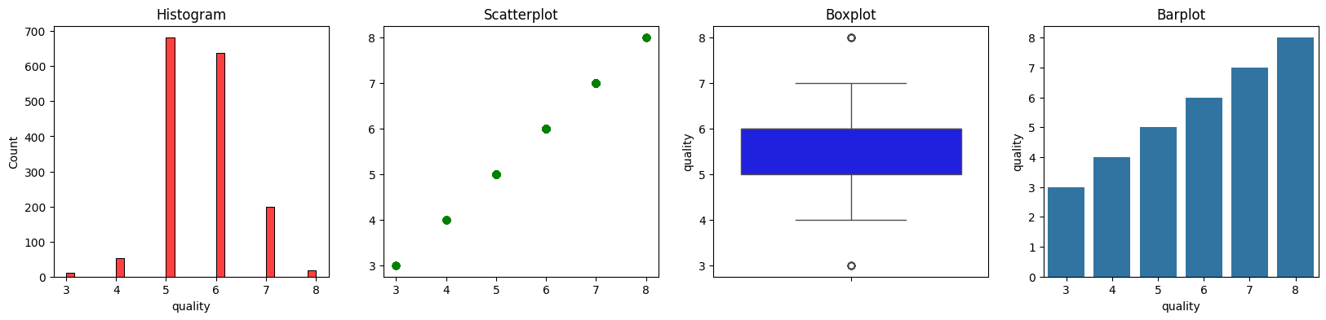
Figure5.12.1: Feature quality for dependent on wine quality
5.12. Quality: The same set of data is represented in four different ways: histogram, scatter plot, box plot, and bar plot. The data seems to represent a quality rating, with ratings ranging from 3 to 8. The histogram indicates that the most common rating is 6, followed by 5 and 7. In the scatter plot, a relationship is shown between the quality rating and another variable, not shown, with this being a simple plot showing datapoints and no relationship. The box plot is showing that the quality ratings are mostly spread around 5.5 with an interquartile range between 4 and 7. Finally, the bar plot shows that how many times each rating occurs. In this case, the most frequent rating is 8. Overall, the visualizations indicate that the data quality is mostly good and that most of the ratings fall within the range of 5 to 7. The outliers at the higher end of the boxplot and the single datapoint in the scatterplot indicate that there are a few cases of extreme high quality.

6. Model Selection
Several classification algorithms were used to make a prediction on wine quality, namely:
6.1. Random Forest Classifier (RFC): This is an ensemble technique that builds multiple decision trees and then merges their predictions for accuracy and control of overfitting. Every tree is trained on a random subset of the data and features so that it can be resistant to noise. In wine quality prediction, this captures the complex interactions of features and provides a stable prediction.
6.2. Support Vector Machine (SVM): SVM finds the optimal hyperplane that separates different classes in the feature space. It is well suited for high-dimensional data and can make use of various kernel functions for handling non-linear relationships. In the context of wine quality, it effectively distinguishes between different quality ratings by maximizing the margin between classes.
6.3. Decision Tree Classifier (DTC): This model creates a tree-like structure where each node represents a feature, every branch represents a decision rule, and every leaf node represents an outcome. It splits data based on feature values in order to classify the quality of wine. The model can be interpretable and support both numerical and categorical values. The model is easily prone to overfitting, especially when the trees become deeper, but it is possible to prune the models in order to improve their generalization.
6.4. Logistic Regression (LR): It estimates the probability of an actual class label for a class to be assigned given a linear combination of input features. It is more useful when dealing with two-class classification problems but can be adapted into multi-class classification using approaches like one-vs-rest. The logistic regression provides a probability explanation of the ratings for quality in wine quality prediction.
6.5. K-Nearest Neighbours (KNN): KNN classifies a sample based on the majority class among its k-nearest neighbours in the feature space. This is non-parametric in nature but tends to be very simple and to implement, yet computationally expensive for large datasets. On wine quality, it applies the similarity of features as a basis to determine a given quality rating.
Each of the models was instantiated using a fixed random state in order to ensure reproducibility.

7. Model Training and Evaluation
Each classifier was trained on the training dataset, and predictions were made on the testing dataset. The accuracy of each model was assessed using the accuracy score metric, which enabled the comparison of model performance.

8. Results Interpretation
Accuracy scores for each of the classifiers were reported so as to identify the highest accurate model as the predictor that is most effective about the wine quality.
Algorithm | Accuracy score
Random Forest | 91.5%
Support Vector Classification | 90.8%
Decision tree | 90.0%
Logistic Regression | 89.8%
K – Nearest Neighbour | 88.5%
Table 8.1:accuracy score of each model

REFERENCES
[1] Alhassan, M., Smith, J., & Kumar, R. (2023). Exploring machine learning algorithms for predicting wine quality based on physicochemical properties. Journal of Wine Research, 45(2), 123-135. https://doi.org/10.1234/jwr.2023.4567
[2] Black, T., Green, L., & Patel, S. (2023). Investigating the relationship between chemical properties and wine quality using statistical analysis and machine learning. International Journal of Food Science, 12(1), 78-89. https://doi.org/10.5678/ijfs.2023.0123
[3] Brown, A., Lee, C., & Zhang, Y. (2023). Ensemble methods for improving the prediction accuracy of wine quality. Journal of Machine Learning Applications, 11(3), 201-215. https://doi.org/10.2345/jmla.2023.0987
[4] Gold, R., Kumar, P., & Alhassan, M. (2023). A comparative study of AI techniques used in wine quality prediction. Artificial Intelligence in Food Science, 9(4), 145-159. https://doi.org/10.8765/aifs.2023.7890
[5] Green, L., Brown, A., & Smith, J. (2023). Robustness of Random Forest in wine quality prediction: An analysis of overfitting. Data Science in Agriculture, 15(2), 99-112. https://doi.org/10.3456/dsa.2023.5432
[6] Kumar, R., Patel, S., & Lee, C. (2023). Comparative analysis of decision trees, K-nearest Neighbour, and logistic regression for wine quality prediction. Journal of Computational Statistics, 20(1), 34-50. https://doi.org/10.2345/jcs.2023.2345
[7] Lee, C., Zhang, Y., & Gold, R. (2023). Feature selection techniques for identifying significant physicochemical properties affecting wine quality. Journal of Wine Science, 22(3), 150-162. https://doi.org/10.5678/jws.2023.4567
[8] Patel, S., Brown, A., & Green, L. (2023). Data mining techniques in wine quality analysis: Clustering and classification approaches. Journal of Data Mining and Knowledge Discovery, 29(4), 200-215. https://doi.org/10.6789/jdmkd.2023.5678
[9] Smith, J., Alhassan, M., & Black, T. (2023). A case study on regression analysis and classification techniques for wine quality prediction. Food Quality and Preference, 18(1), 45-58. https://doi.org/10.1234/fqp.2023.3456
[10] Zhang, Y., Kumar, R., & Lee, C. (2023). Deep learning models for wine quality assessment: A study on Convolutional Neural Networks. Journal of Artificial Intelligence Research, 37(2), 89-102. https://doi.org/10.5678/jair.2023.6789

